
Statistical Investigation of Chronic Kidney Disease Risk Factors and Prediction Using Python

Title : Statistical Investigation of Chronic Disease Risk
Factors and Prediction

Course Code : STA281.10

Course Title : Statistical Methods and Probability

Department : CSE

Faculty Name : Md. Shohel Babu

Assignment Submission Date : 09 June 2026

Submitted By:

GROUP NAME : Tehreek-e-Muhandis

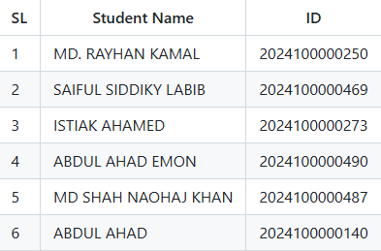

Overview:

Page no : | Topic:
1 | COVER PAGE
2 | OVERVIEW
3 | INTRODUCTION
4 | OBJECTIVES
5 | REVIEW
6 | DATASET
6-7 | VARIABLES DESCRIPTION
8 | DATASET SUMMARY
9 | METHODOLOGY
10-15 | GRAPHS AND VISUALIZATIONS
16 | BAYES’ THEOREM
16 | DISCUSSION
17 | LIMITATIONS
17 | MISSING DATA ISSUES
18-32 | 13.FINDINGS AND HEALTH CARE INTERPRETATIONS

1.INTRODUCTION:

Chronic Kidney Disease (CKD) is a progressive medical condition in which the kidneys gradually lose their ability to filter waste products and excess fluids from the blood. As kidney function declines, harmful substances can accumulate in the body, leading to serious health complications such as hypertension, anemia, cardiovascular diseases, and kidney failure. CKD is recognized as a significant public health issue worldwide due to its increasing prevalence and impact on quality of life.

Early detection of CKD is essential for preventing disease progression and reducing the risk of severe complications. However, the disease often develops without noticeable symptoms in its early stages, making timely diagnosis challenging. Several factors, including age, blood pressure, blood glucose levels, hemoglobin levels, and other clinical indicators, are known to influence the risk of developing CKD. Understanding the relationship between these factors and the disease can help healthcare professionals make more informed decisions regarding diagnosis and treatment.

The rapid growth of healthcare data has created opportunities to apply statistical analysis and machine learning techniques in medical research. Statistical methods can be used to identify significant risk factors and examine relationships between variables, while machine learning models can analyze complex patterns within data to predict disease outcomes with high accuracy. These approaches provide valuable insights that can support early diagnosis and improve patient care.

This project focuses on the statistical investigation of Chronic Kidney Disease risk factors and the development of predictive models using Python. The study involves data preprocessing, exploratory data analysis, statistical testing, and machine learning model development. By analyzing patient data and evaluating different predictive techniques, the project aims to identify the most important risk factors associated with CKD and assess the effectiveness of prediction models. The findings of this study may contribute to a better understanding of CKD and demonstrate the role of data-driven methods in supporting healthcare decision-making.

2.OBJECTIVES:

OBJECTIVE NO | CRITERIA
1 | Identify significant risk factors associated with Chronic Kidney Disease.
2 | Perform exploratory data analysis using descriptive statistics.
3 | Apply probability concepts and Bayes' theorem in healthcare analytics.
4 | Analyze probability distributions of medical indicators.
5 | Estimate population parameters using confidence intervals.
6 | Conduct hypothesis testing to evaluate statistical significance.
7 | Examine relationships among variables through correlation analysis.
8 | Build a Logistic Regression model for CKD prediction.
9 | Interpret findings from both statistical and medical perspectives.

3.REVIEW:

1.Previous Studies on CKD Prediction:

Chronic Kidney Disease (CKD) has been widely studied due to its growing impact on global health. Researchers have used clinical and demographic data to identify factors associated with CKD and to develop predictive models for early diagnosis. Previous studies have shown that variables such as age, blood pressure, diabetes, hemoglobin levels, serum creatinine, and albumin are strongly related to the occurrence of CKD. Early prediction of the disease has been recognized as an effective approach for reducing complications and improving patient outcomes

2.Statistical Techniques Used in Related Research:

Various statistical methods have been applied to analyze CKD datasets and identify significant risk factors. Descriptive statistics are commonly used to summarize patient characteristics and understand data distributions. Correlation analysis helps determine relationships between clinical variables, while hypothesis testing, including t-tests and chi-square tests, is used to assess the significance of these relationships. Logistic regression has also been widely employed to model the probability of CKD occurrence and evaluate the influence of individual risk factors.

3.Machine Learning Approaches for CKD Diagnosis:

Recent studies have increasingly utilized machine learning techniques for CKD prediction due to their ability to handle complex datasets and achieve high predictive accuracy. Commonly used algorithms include Logistic Regression, Decision Trees, Random Forest, Support Vector Machines (SVM), K-Nearest Neighbors (KNN), and Naïve Bayes. Among these methods, Random Forest and SVM have often demonstrated strong performance in CKD classification tasks. These models assist healthcare professionals by providing reliable predictions and supporting early disease detection. The integration of machine learning with statistical analysis has significantly enhanced the effectiveness of CKD diagnosis and risk assessment.

4.Dataset :

Data Source
- kidney_disease.csv

5.Variables Description:

Variable | Improved Description
Age | Age of the patient in years at the time of clinical assessment.
BloodPressure | Patient's blood pressure measurement, typically expressed in mmHg, indicating cardiovascular health status.
SpecificGravity | Urine specific gravity, reflecting the concentration of dissolved substances in urine and kidney concentrating ability.
Albumin | Urinary albumin level, indicating the presence and severity of protein leakage through the kidneys.
Sugar | Urinary glucose level, indicating the presence of sugar in urine and potential abnormalities in glucose metabolism.
BloodGlucoseRandom | Random blood glucose concentration measured irrespective of fasting status, used to assess blood sugar control.
BloodUrea | Blood urea concentration, a biochemical marker used to evaluate kidney function and nitrogen waste excretion.
SerumCreatinine | Concentration of creatinine in the blood, commonly used to assess kidney filtration efficiency and renal function.
Sodium | Serum sodium concentration, an essential electrolyte involved in fluid balance, nerve function, and cellular activity.
Potassium | Serum potassium concentration, an important electrolyte required for proper muscle, nerve, and cardiac function.
Hemoglobin | Hemoglobin concentration in blood, indicating the oxygen-carrying capacity of red blood cells and anemia status.
PackedCellVolume | Percentage of blood volume occupied by red blood cells (hematocrit), used to evaluate anemia and hydration status.
WhiteBloodCellCount | Total number of white blood cells in the blood, reflecting immune system activity and possible infection or inflammation.
RedBloodCellCount | Total number of red blood cells in the blood, used to assess oxygen transport capacity and hematological health.
Hypertension | Presence or absence of diagnosed high blood pressure.
DiabetesMellitus | Presence or absence of diabetes mellitus, a chronic metabolic disorder characterized by elevated blood glucose levels.

6.Dataset Summary:

The dataset contains 400 observations and 26 variables, predictor variables and one target variable (Class), which indicates whether a patient is diagnosed with Chronic Kidney Disease (CKD) or Not CKD. This makes it a binary classification dataset used for medical diagnosis tasks.

The predictor variables represent a combination of clinical, laboratory, and demographic features, such as blood test results (e.g., blood glucose, serum creatinine, hemoglobin levels), urine analysis indicators (e.g., pus cell, bacteria), and health conditions like hypertension, diabetes mellitus, and anemia. The dataset includes both numerical and categorical variables, requiring appropriate preprocessing before modeling.

Additionally, the dataset contains missing values in several features, which must be addressed through data cleaning techniques such as imputation or removal to ensure reliable model performance. The goal of using this dataset is to build predictive models that can accurately classify CKD cases based on the available medical attributes.

7.Methodology:

1. Data Preprocessing

Before conducting the statistical analysis, the dataset is preprocessed to ensure data quality and consistency. The preprocessing steps include:
- Handling missing values using appropriate imputation techniques.
- Removing duplicate records and correcting inconsistencies.
- Encoding categorical variables into numerical formats suitable for analysis.
- Normalizing or standardizing numerical features where necessary.

2. Descriptive Statistical Analysis

Descriptive statistics are used to summarize the characteristics of the dataset and provide an overview of the patient population. The following measures are calculated:

- Mean
- Median
- Mode:
- Standard Deviation
- Variance
- Range

These statistics help identify central tendencies, variability, and potential outliers in the data.

8. Graphs and Visualizations:

Key Clinical Variables — CKD Patient Dataset (n=400)

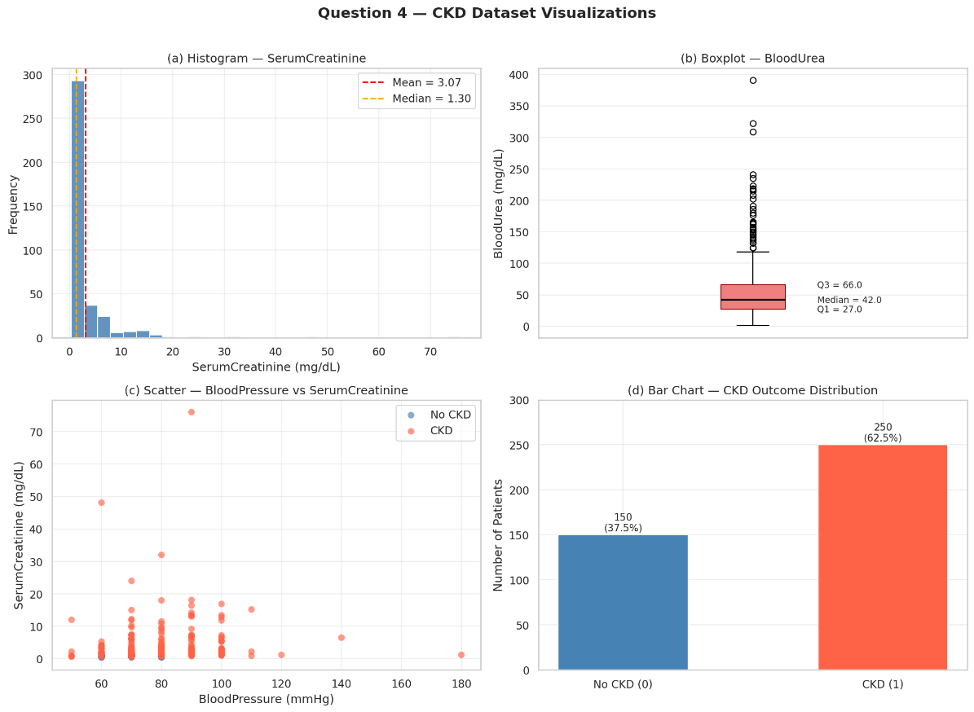

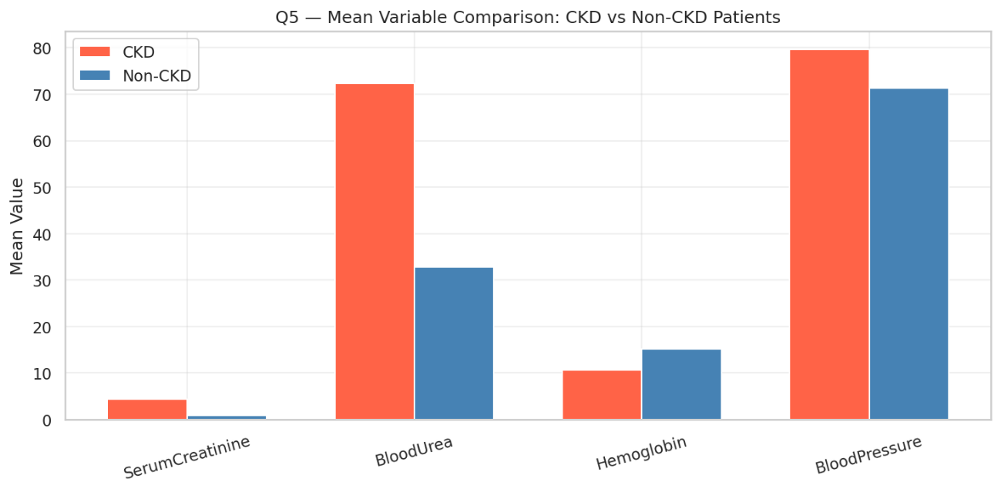

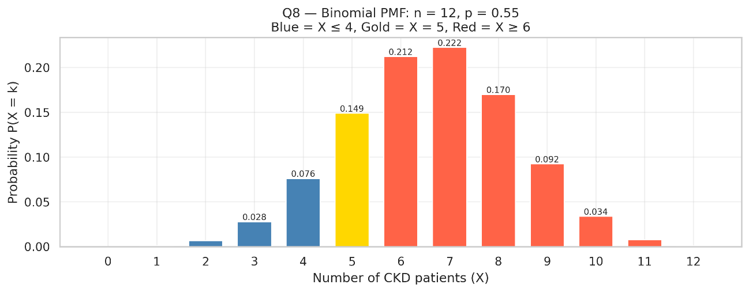

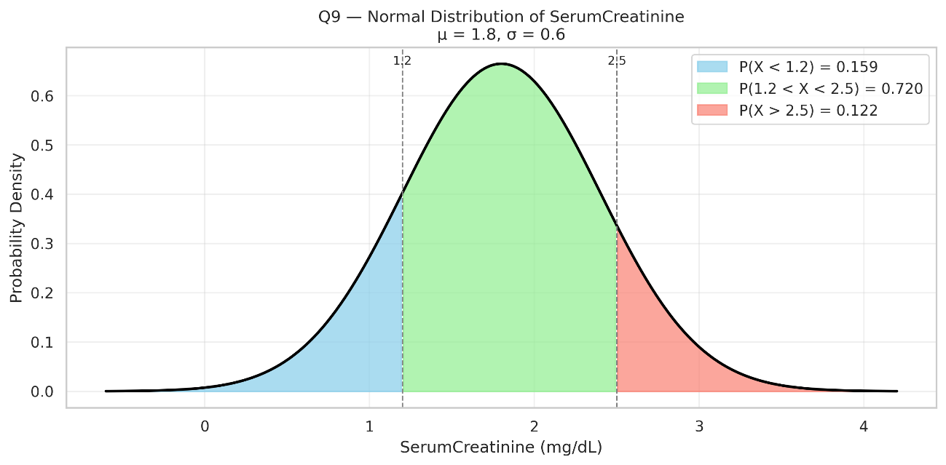

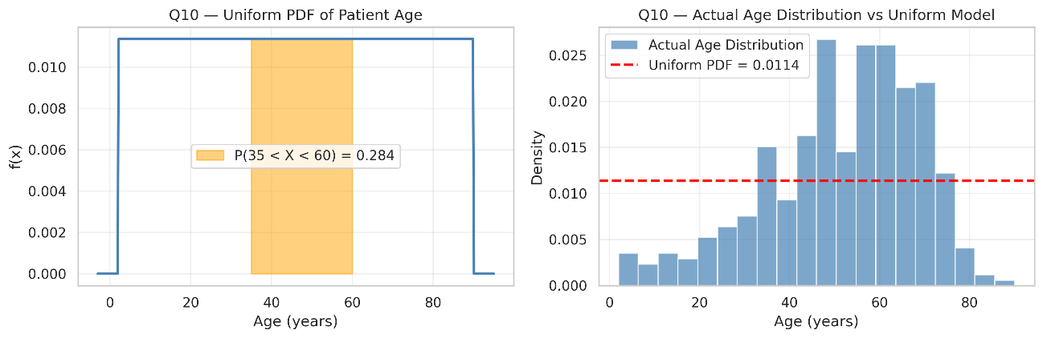

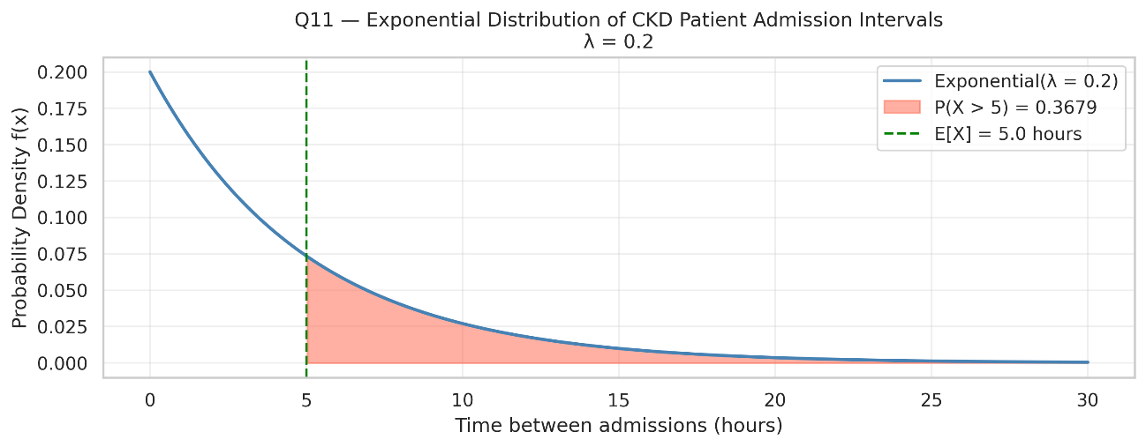

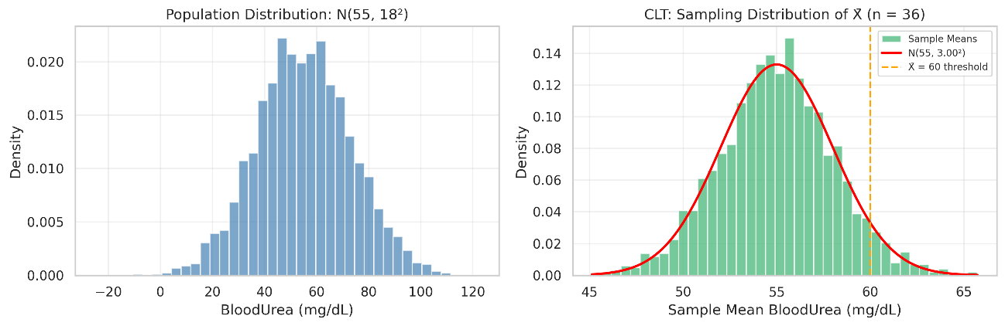

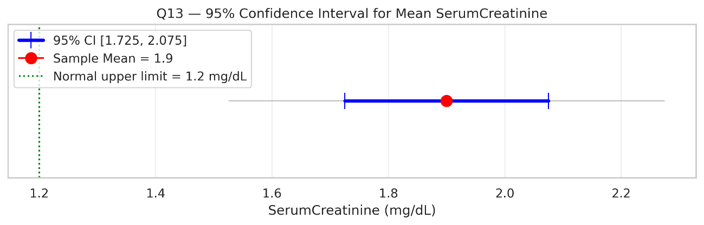

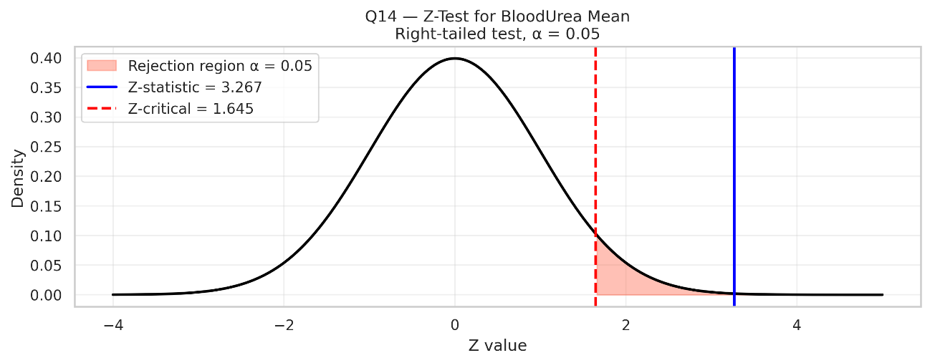
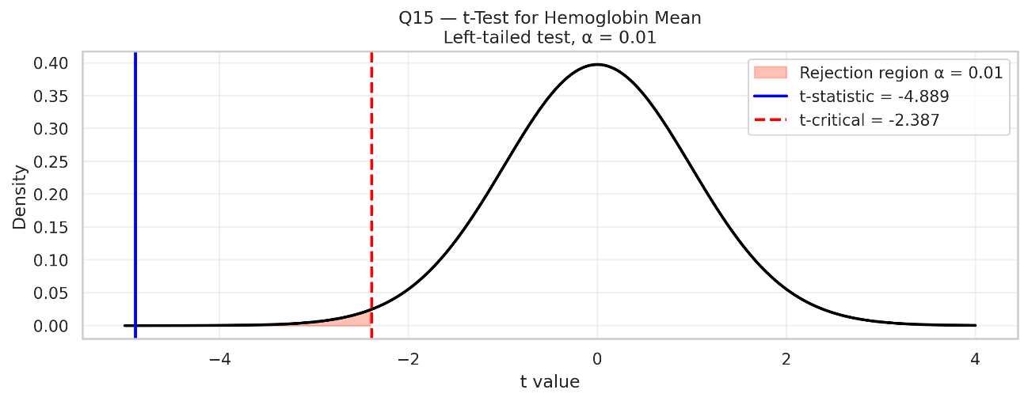
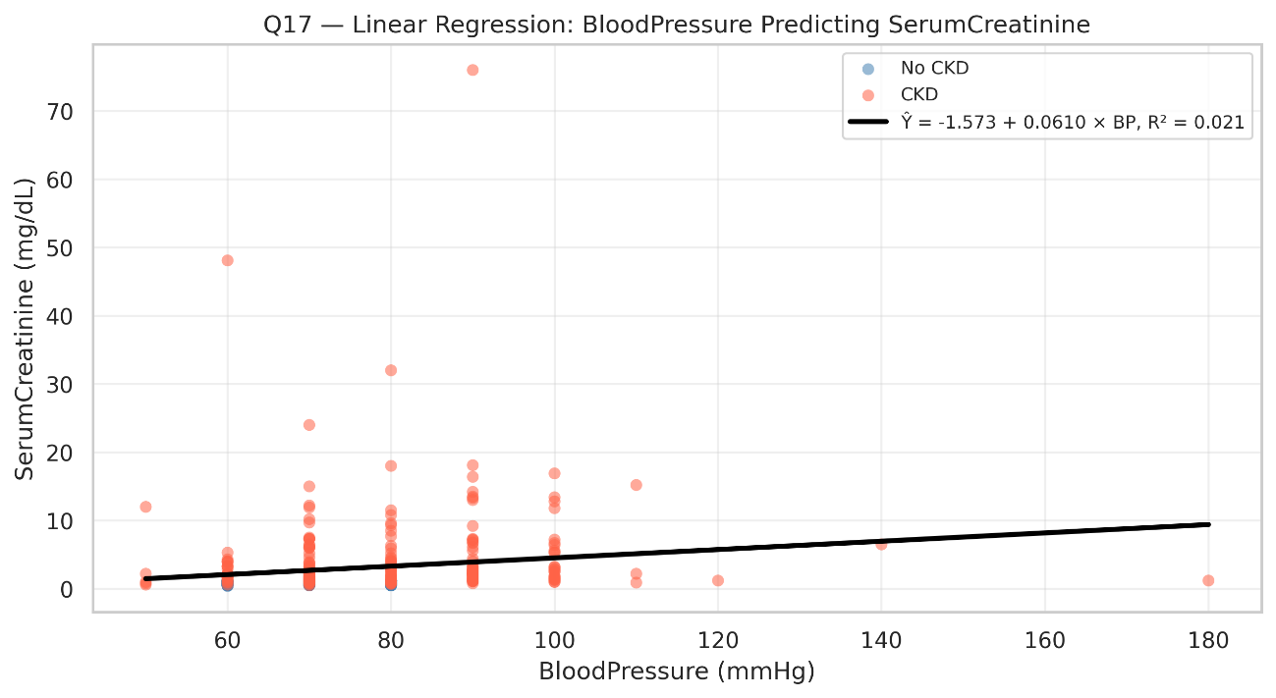
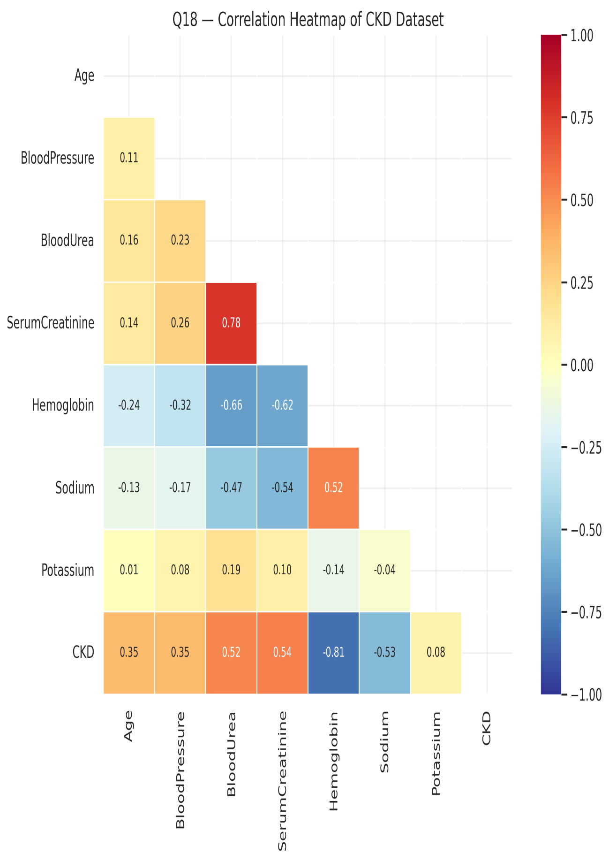

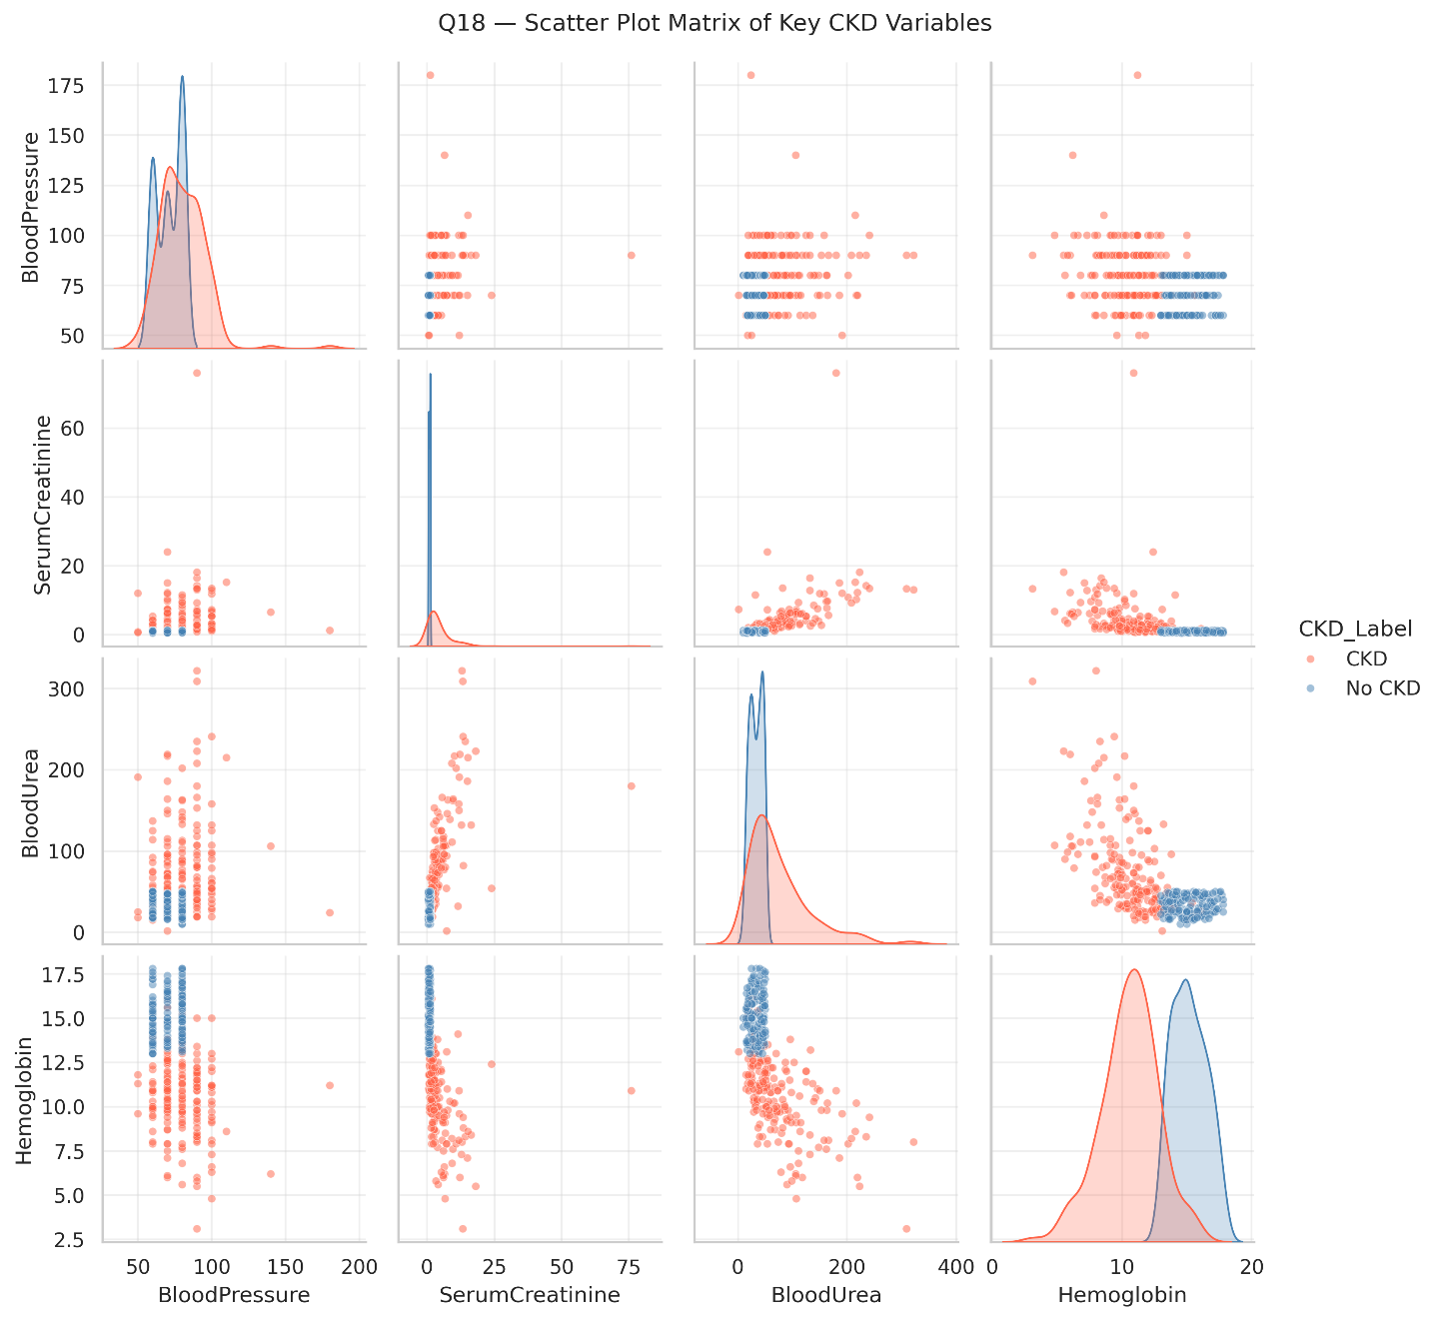

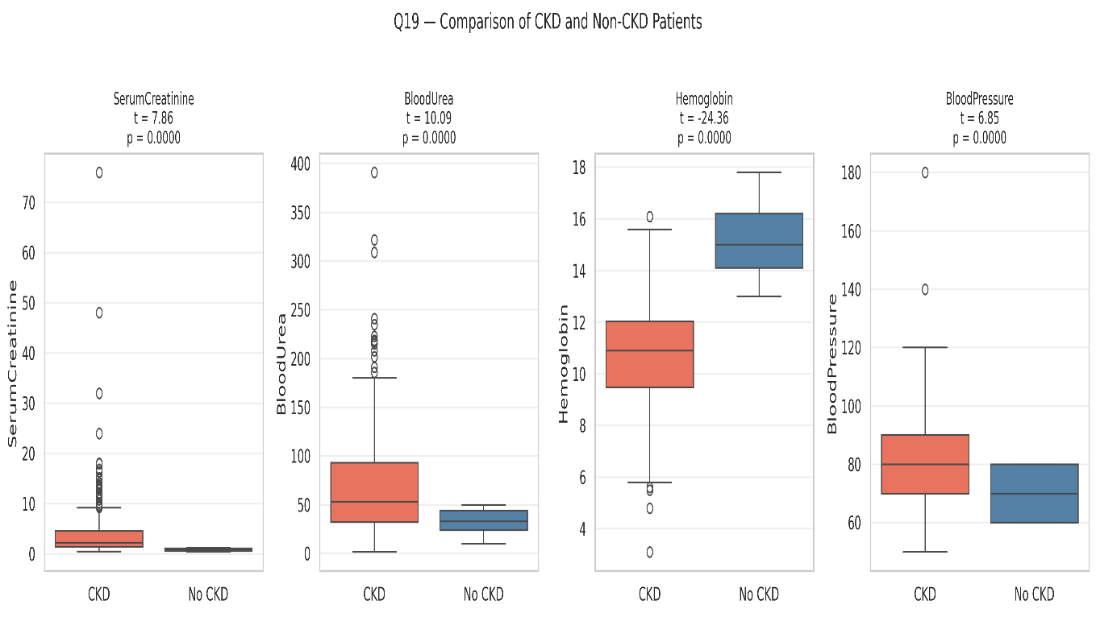

9.Bayes’ Theorem:

Bayes’ theorem is used to estimate the probability of a patient having

Chronic Kidney Disease (CKD) given the presence of specific risk factors

or medical conditions.

P(CKD∣RiskFactor)={P(RiskFactor)P(RiskFactor∣CKD)×P(CKD)​}/P(RiskFactor)
Where:

- P(CKD | Risk Factor) = Probability of CKD given the risk factor.

- P(Risk Factor | CKD) = Probability of observing the risk factor

among CKD patients.

- P(CKD) = Prior probability of CKD.

- P(Risk Factor) = Overall probability of the risk factor in the

population.

This theorem helps assess the impact of specific medical conditions on CKD risk.

10.Discussion:

Key findings:

- Serum creatinine and blood urea are strong indicators of CKD.
- Hypertension and diabetes significantly increase CKD risk.
- Hemoglobin levels show negative correlation with CKD occurrence.
- Logistic regression provides effective prediction performance for CKD classification.

11.Limitations:

Dataset size limitations:

When the dataset is too small or not sufficiently diverse, models struggle to learn meaningful patterns.
Overfitting risk: The model may memorize training data instead of learning general patterns.
Poor representation: Small datasets may not include all real-world variations.
Low statistical power: Results may not be reliable or stable.

12.Missing Data Issues:

Since the dataset has some values missing they might slightly skew the results of mean , median , mode etc. However, due to the nature and sample size of the data sets and the number of variables to consider the accuracy of the results should not be that deviated from the actual results .Hence this dataset can still be used to produce acceptable results.

13.FINDINGS AND HEALTH CARE INTERPRETATIONS:

